**Cluster Auto-Scaler**

**Step 1:** create an eks cluster by using the following cmd

eksctl create cluster --asg-access --name my-cluster-1 --asg-access --nodes-max 4 --nodes-min 1 --nodes 3 --node-type t2.small --nodegroup-name Node-group-A --ssh-access --enable-ssm --version 1.25 --region ap-southeast-1



Check whether the nodes are created

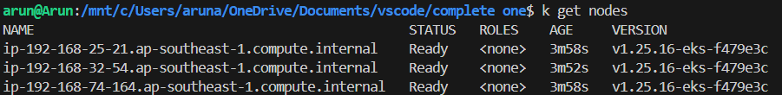

Step 2: Create an IAM OIDC provider for your cluster

Refer: <https://docs.aws.amazon.com/eks/latest/userguide/enable-iam-roles-for-service-accounts.html>

* cluster_name=my-cluster-1
* oidc_id=$(aws eks describe-cluster --name $cluster_name --query "cluster.identity.oidc.issuer" --output text | cut -d '/' -f 5)
* echo $oidc_id
* aws iam list-open-id-connect-providers | grep $oidc_id | cut -d "/" -f4
* eksctl utils associate-iam-oidc-provider --cluster $cluster_name –approve

Step 3:

clone the git <https://github.com/arun037/cluster-autoscaler.git>

Edit the cluster-autoscaler.yaml with your cluster name

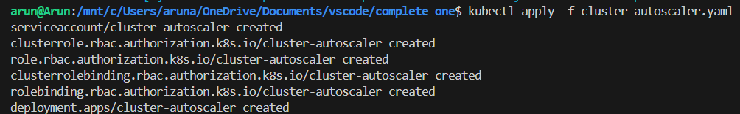

After applying the auto-scaler the empty nodes are removed and only desired number will be present





Step 4: To add the cluster-autoscaler.kubernetes.io/safe-to-evict annotation, patch the deployment as follows

kubectl patch deployment cluster-autoscaler \

-n kube-system \

-p '{"spec":{"template":{"metadata":{"annotations":{"cluster-autoscaler.kubernetes.io/safe-to-evict": "false"}}}}}'

Step 5:

kubectl set image deployment cluster-autoscaler -n kube-system cluster-autoscaler=registry.k8s.io/autoscaling/cluster-autoscaler:latest



step 6: check for the logs

kubectl logs -n kube-system deployment.apps/cluster-autoscaler

**Next we want to install metric server**

kubectl apply -f <https://raw.githubusercontent.com/ACloudGuru-Resources/content-cka-resources/master/metrics-server-components.yaml>

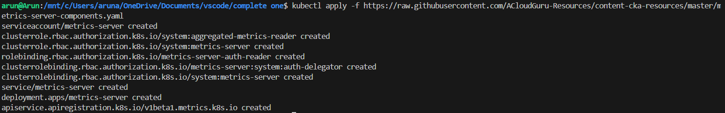

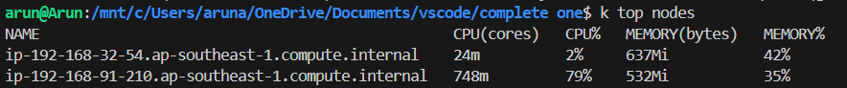

Check how many pods are running



Now create HPA



**Then increase the load by**

kubectl run -i --tty load-generator --rm --image=busybox:1.28 --restart=Never -- /bin/sh -c "while sleep 0.01; do wget -q -O- http://php-apache; done"



then take another tab

check for nodes and pods by

kubectl get po

kubectl get nodes

kubectl get events – to check the log

